**Shop Database Design**

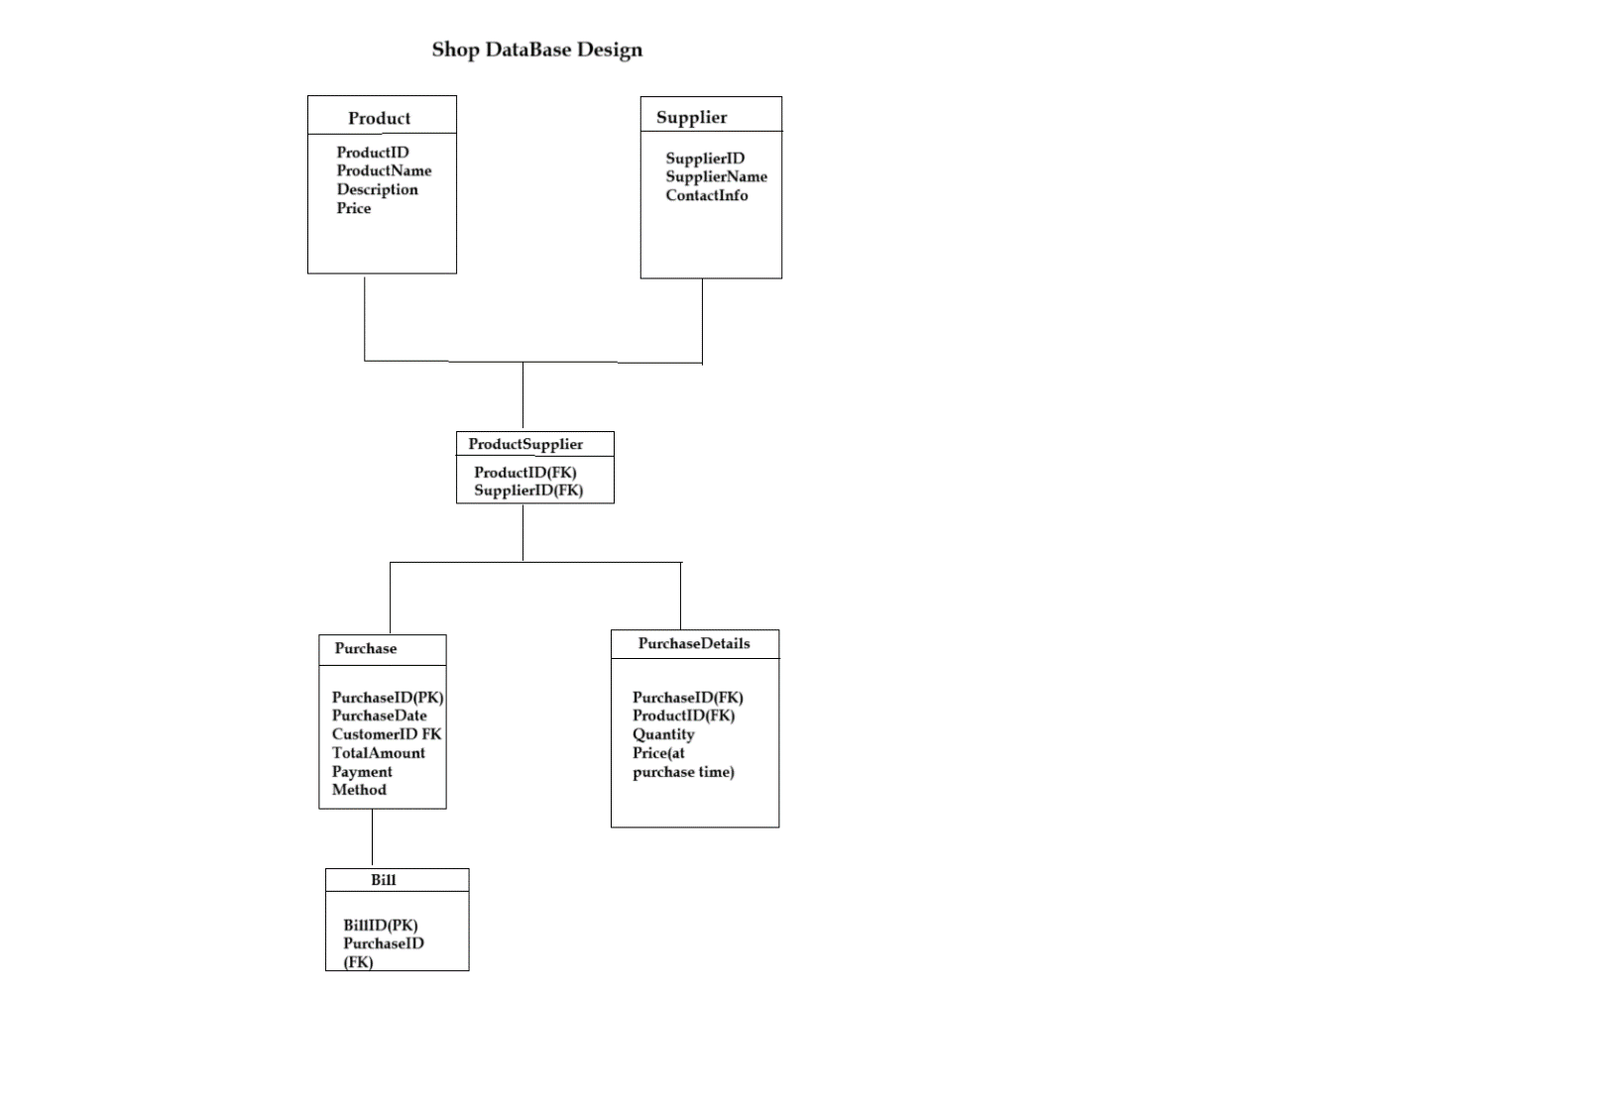

**Movie Store**

Movie

Store

StoreName

Phone

Movie

MovieNumber

Title

Format

Category

Member

MemberID (PK)

Name

FavoriteCategory

MemberType

BronzeMember

GoldenMember

Payment

Payment

CreditCardNumber

Dependent

DependentName

Rental

RentalID

RentalDate

ReturnDate

**Student Registration System**

